**PJ 2 Report My Name: Francisco Valadez**

**A. The following is my Java program with colors:**

**// You must copy your Java program from Eclipse into here so that it is colored.**

**// You must not show screen prints here.**

**B. The following is the complete output of my 3 test cases.**

**// Please copy your complete console output and paste into here for each test case.**

//Author: Francisco Valadez  
//Date: 5/5/2021  
//Purpose: This program creates a student GPA report.  
  
import java.util.Scanner;  
  
import org.w3c.dom.css.Counter;  
  
public class Student_GPA  
{  
 static String[] sidA = new String[12]; // 5 static parallel arrays of 12 items each  
 static String[] lnameA = new String[12];  
 static String[] fnameA = new String[12];  
 static double[] gpaA = new double[12];  
 static String[] phoneA = new String[12];  
  
 public static void main(String[] args)  
 {  
 int counter = 0;  
 String studentID, lastName, firstName, phoneNumber;  
 double GPA = 0, averageGpa = 0;  
   
 Scanner scan = new Scanner (System.in);  
 System.out.println("Welcome to the Student GPA System of Francisco Valadez!");  
   
 do  
 {  
 System.out.println(counter + 1 + "=====================================================");  
 System.out.println(">>Please enter student id, lastname, firstname, GPA and phone number>");  
 studentID = scan.next();  
 lastName = scan.next();  
 firstName= scan.next();  
 GPA = scan.nextDouble();  
 phoneNumber = scan.next();  
   
 //Checks if user wants to quit the program  
 if (studentID.equals("0"))  
 break;  
   
 //Creates a student  
 Student info = new Student(studentID, lastName, firstName, GPA, phoneNumber, counter);  
   
 //System.out.println("SID: " + studentID + "\nLast Name: "+ lastName + "\nFirst Name: " + firstName + "\nGPA: " + GPA + "\nPhone:" + phoneNumber);  
   
   
 ++counter;  
 } while(counter < 10);  
 System.out.println( counter + 2 + "====================================================");  
 System.out.println( "Student GPA Report: \n" + "\n" +  
 "ID\tLast Name\tFirst Name\tGPA\tPhone Number" + "\n" +  
 "----- -------------- ---------------- -------- ------------");  
 for (int x = 0; x < counter; x++)  
 {  
 System.out.println(sidA[x] + "\t"+ lnameA[x] + "\t\t" + fnameA[x] + "\t" + gpaA[x] + "\t" + phoneA[x]);  
 averageGpa += gpaA[x];  
 }  
   
 System.out.println("\nThe Average GPA of the above " + counter + " students is " + ((int)((averageGpa/counter)*10000))/10000.0);  
   
 System.out.println(3 + counter + "====================================================.");  
 System.out.println("Thank you for using the Student GPA System of Francisco Valadez!");  
 System.out.println(4 + counter + "====================================================.");  
 }  
}  
  
//This class holds the constructor, getters and setters for the student's information  
class Student  
{  
 private static int countStudents = 0; // count the total number of students  
 private static double totalGpa = 0.0; // total GPA sum of all students. Donâ€™t use float   
 private static double averageGpa = 0.0; // average GPA of all students. Donâ€™t use float  
 String studentID;  
 String lastName;  
 String firstName;   
 double GPA;   
 String phoneNumber;  
 Student_GPA student = new Student_GPA();  
   
 public Student(String studentID, String lastName, String firstName, double GPA, String phoneNumber, int counter)  
 {  
 //keeps track of number of students  
 countStudents++;  
 //5 Setters  
 setSID(studentID, counter);  
 setLastName(lastName, counter);  
 setFirstName(firstName, counter);  
 setGPA(GPA, counter);  
 setPhoneNumber(phoneNumber, counter);  
   
 //Prints the new students information  
 printStudentRecord(counter);  
   
 //caculates the gpa and displays the current student count  
 totalGpa += GPA;  
 averageGpa = totalGpa / countStudents;  
 System.out.println("\nCurrent Student Count: " + countStudents + ", Total GPA: " + totalGpa +   
 ", Average GPA: " + averageGpa);  
   
 }  
  
 //prints the new studetns information  
 void printStudentRecord(int counter)  
 {  
 System.out.print("Student id: " + student.sidA[counter] + ", Last Name: " + student.lnameA[counter] + ", First Name: " + student.fnameA[counter]  
 + ", GPA: " + student.gpaA[counter] + ", Phone Number: " + student.phoneA[counter]);  
 }  
  
 //5 setters  
 void setSID(String studentId, int counter)  
 {  
 //this.studentId = SID;  
 //student.sidA[counter] = this.studentId;  
 student.sidA[counter] = studentId;  
 //System.out.print("Student id: " + studentId);  
 }  
 void setLastName(String lastName, int counter)  
 {  
 student.lnameA[counter] = lastName;  
 //System.out.print(", Last Name: " + lastName);  
 }  
 void setFirstName(String firstName, int counter)  
 {  
   
 student.fnameA[counter] = firstName;  
 //System.out.print(", First Name: " + firstName);  
 }  
 void setGPA(double GPA, int counter)  
 {  
 student.gpaA[counter] = GPA;  
 //System.out.print(", GPA: " + GPA);  
 }  
 void setPhoneNumber(String phoneNumber, int counter)  
 {  
 student.phoneA[counter] = phoneNumber;  
 //System.out.print(", Phone Number: " + phoneNumber);  
 }  
  
 //5 getters  
 public String getSID(String studentID, int counter)  
 {  
 return student.studentID[counter];  
 }  
 public String getLastName(String lastName, int counter)  
 {  
 return student.lnameA[counter];  
 }  
 public String getFirstName(String firstName, int counter)  
 {  
 return student.fnameA[counter];  
 }  
 public double getGPA(double GPA, int counter)  
 {  
 return student.gpaA[counter];  
 }  
 public String getPhoneNumber(String phoneNumber, int counter)  
 {  
 return student.phoneA[counter];  
 }  
}

**Test Case 1:**

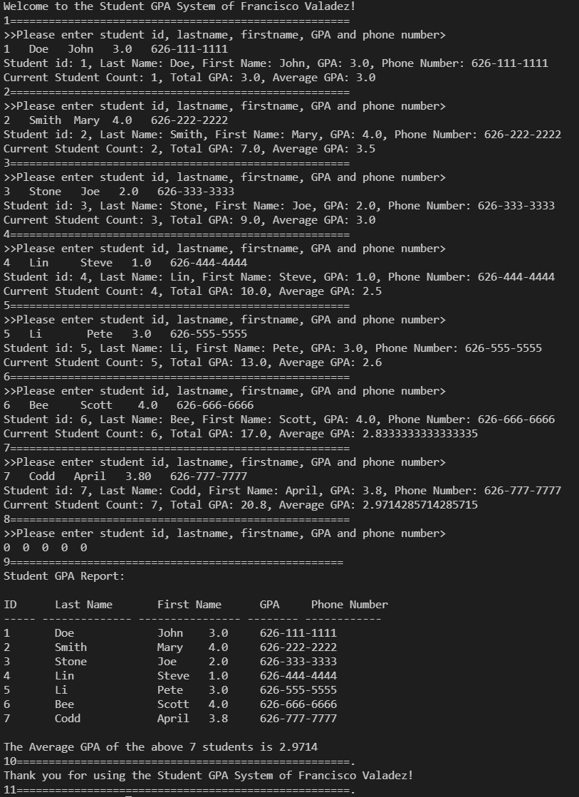

**Test Case 2:**

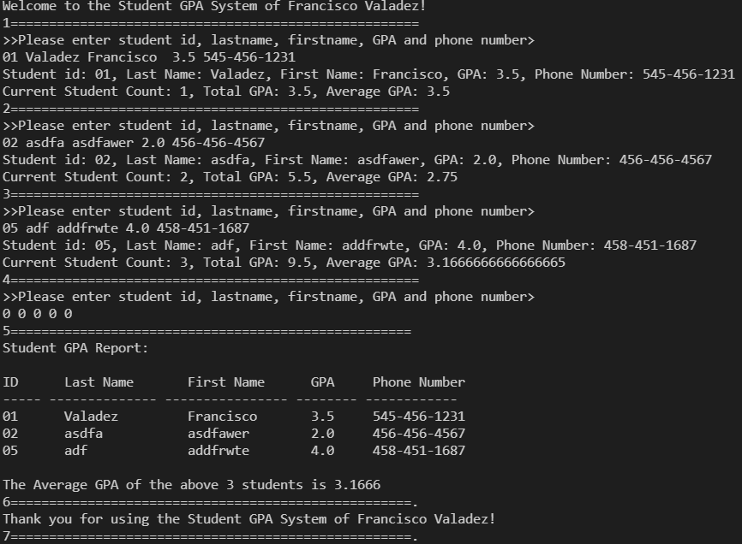

**Test Case 3:**

